# Android practicum part 1.2: Getting to work

## Android Hello World

Ok, all the tools are in place so let’s get started with a Hello World.

Luckily Google has create a nice Hello World tutorial.

Start here

* <http://developer.android.com/training/basics/firstapp/index.html>

Continue with this (Create a Project with Command Line Tools is optional)

* <http://developer.android.com/training/basics/firstapp/creating-project.html>

When finished continue with this (If you don’t have a device, just use the emulator:

* <http://developer.android.com/training/basics/firstapp/running-app.html>

Finally go here:

* <http://developer.android.com/training/basics/firstapp/starting-activity.html>

When you are done, make sure that the project is added to your repository.

## Playing with Layout

Ok, the hello world is done. But the UI is a bit empty.

* Create a new Android project. A good name would be: Android_components
* Open the activity_main.xml layout using the Graphical Layout view.

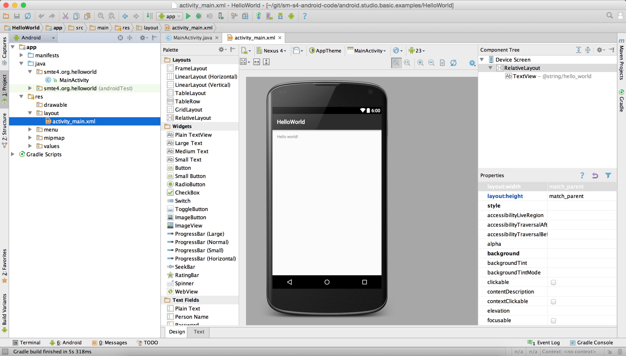Fig 1: Example of adding an activity using Android Studio.

* Add a number of different components on the view (At least 4)

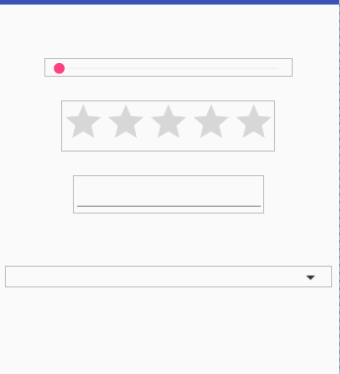

Now go to developer.android.com and find the official documentation for the UI components you’ve found, and paste the URL’s below.

Links:

<https://developer.android.com/reference/android/widget/SeekBar.html>

<https://developer.android.com/reference/android/widget/RatingBar.html>

<https://developer.android.com/reference/android/widget/EditText.html>

<https://developer.android.com/reference/android/widget/Spinner.html>

## To conclude

Make sure that this document is uploaded within your repository.